Evaluating a News Source
On 8 November 2016, Twitter user “Simon Rowntree” posted a message claiming that supporters were chanting “we hate Muslims, we hate Blacks, we want our great country back” at a post-election victory rally for Donald Trump:
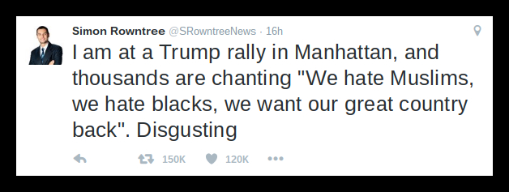

How should we evaluate whether this claim is true or false? Whether this is real news or fake news?

http://www.snopes.com/trump-rally-chant/

