Group A – Practice

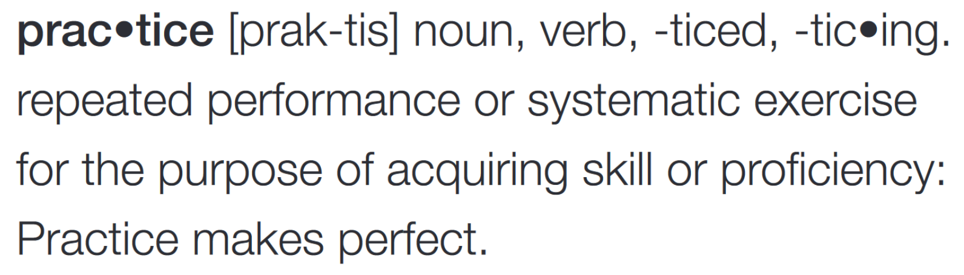
If you ask any athlete to define practice, they may not be able to tell you the exact dictionary definition, but they certainly know that practice is critical for learning and improving skills. A softball pitcher may practice her riseball for months to achieve accuracy and consistency, hoping to make an unsuspecting batter swing underneath it. During practice, it doesn’t matter how often the rise-ball flew over the catcher’s head, was out of the strike zone, or ended up in the dirt. With continual feedback from her catcher and coach and focus on the outcome, eventually she’ll master the skill and have a new tool to spring on batters. Acquiring the skill of a killer riseball is what ultimately matters. The amount of hours that it took this pitcher to perfect her craft is irrelevant as long as she’s ready when the situation presents itself at game time.
What seems so logical and implicit in the athletic and performance arena is often foreign in schools, which should provide opportunities for students to practice and perfect new skills. Teachers often weigh practice and performance equally. For example, a student may earn a C on homework assignments and an A on the test. What final grade would this student earn? Many teachers would say a B, an average of the two, equally weighting practice and performance. Can you imagine this same reasoning being applied to the performers in a Broadway play? It would equate to an actress receiving a less than favorable review because she forgot some lines in rehearsal even though she was brilliant in the live performance.
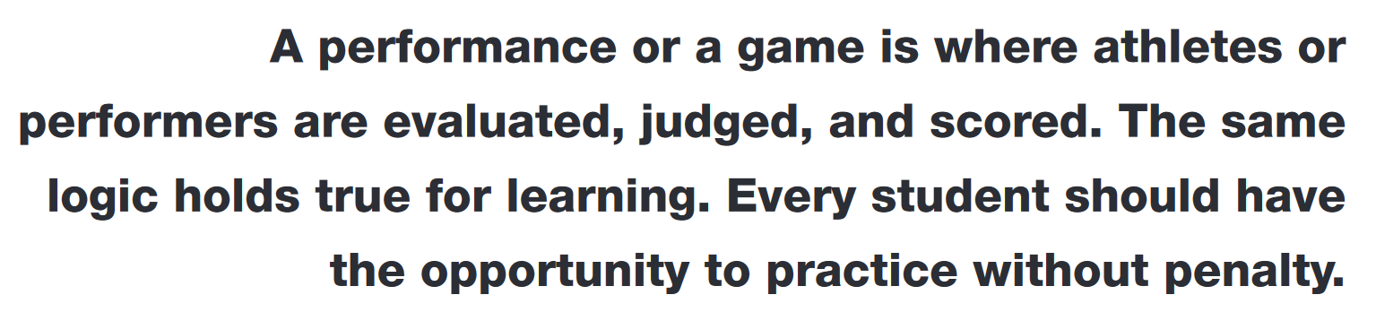

From H. Deddeh, E. Main, & S. Fulkerson, “Eight Steps to Meaningful Grading.” Phi Delta Kappan, April 2010.
Group B – The Case Against Percentage Grades

From the perspective of simple logic, percentage grading scales make little sense….Teachers who use percentage grades typically set the minimum passing grade at 60 or 65. The result is a scale that identifies 60 or more distinct levels of failure and only 40 levels of success. In other words, nearly two-thirds of the percentage grading scale describes levels of failure! What message does that communicate to students? And distinguishing 60 different levels of failure is hardly helpful. Does any teacher consider percentage grades in the 50s to denote modest failure and those in the teens or 20s to represent extreme failure? Are unsuccessful students concerned about which of the 60 different levels of failure they achieved? Some teachers counter that no one really uses those 60 different levels of failure. But if that is the case, then why have them? Why not use a 50-point grading scale and designate ten levels of failure rather than the 100-point percentage grading scale with 60 levels of failure? After all, the choice of 100 is quite arbitrary. A grading scale in which two-thirds of the designated levels describe failure also implies that degrees of failure can be more finely distinguished than degrees of success. Should the focus of educators be to determine more minutely different levels of failure than those of learning success?
Educators at all levels are familiar with integer grades. The majority of colleges and universities in the United States use integer grading systems, and most high schools use integer grades when they compute students’ grade-point averages (GPAs). In fact, using 0–4 integer grades would eliminate the problems that many high schools experience in trying to convert percentage grades to four point or five-point GPAs. And integer grading scales align with the levels used to classify student achievement in most state assessment programs (for example, Below Basic, Basic, Proficient, and Advanced) and with the four point rubrics that many teachers use in judging students’ performance on classroom assessments.

Excerpted from Thomas Guskey, "The Case Against Percentage Grades" (2013). Educational, School, and Counseling Psychology Faculty Publications. 22. http://uknowledge.uky.edu/edp_facpub/22
Group C – Missing Assignments – The Distortion of Zero

"Lates" and Zeros
When addressing punitive grading measures… I will be speaking mainly of deductions for late assignments ("lates") and zeros. Any discussion of zeros must include a distinction between a 4-point scale and 100-point scale. Doug Reeves (2010) explains the difference very well:
On a four-point scale, where "A" = "4," "B" = "3," and so on, the zero is accurate, because the difference between the "A," "B," "C," "D," and "F" are all equal—one point. But assigning a zero on a 100-point scale is a math error; it implies a 60-point difference between the "D" and "F," while the other differences are typically about 10 points. It makes missing a single assignment the "academic death penalty." It's not just unfair—it is not mathematically accurate. (p. 78)
The majority of the zeros I see getting handed out are on a 100-point scale. Both lates and zeros are attempts to affect behavior by statistically incorporating punitive measures into the grading scheme.
Here are some examples of how lates and zeros are typically used in grading decisions:
- 10 percent of the grade is deducted per day after the assignment’s due date.
- A 50 percent deduction is applied to the assignment following an arbitrary number of days beyond the original due date.
- After the due date, the assignment is graded on a pass/fail basis; if awarded a “pass,” 50 percent of the grade is still deducted.
- If the assignment is not handed in by the due date, it receives an automatic zero.
….
It is disturbing that the destructive power of a zero grade is often the reason that teachers use it. If the goal is to punish or compel, a zero is the ultimate numerical weapon. When factored into the average of an otherwise consistent set of scores the results can be considerable.
(He then gives examples of how one zero can be the difference between receiving a C or a failing report card grade.)

From Myron Dueck, Grading Smarter Not Harder, pp. 11-19.

